RPA Practical 2
- Open Uipath studio
- Open and select new process under new project
- It will open a dialogue process (name the project, description ’any’, and then create)
- Main.xaml file is created by default
- All the project related file is present in project.json
- Activities: all the components are present here
- Main sequence is our canvas where we build our workflows
- Data manager: create arguments and variable

Creating Arrays:
Create variable Arnum, datatype array of (T), T type should be integer, default values: {1,2,3,4,5,6,7,8,9,10}
Select For each element, In Arnum, Item name: Number
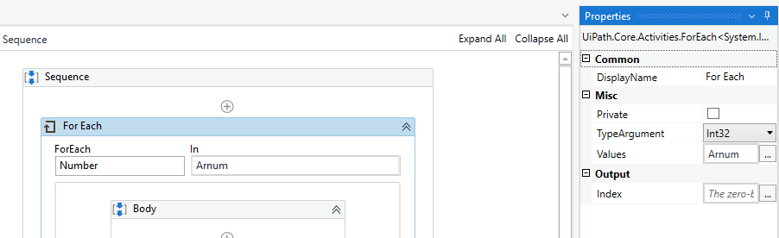
Than select Write line component, text: Number.ToString()
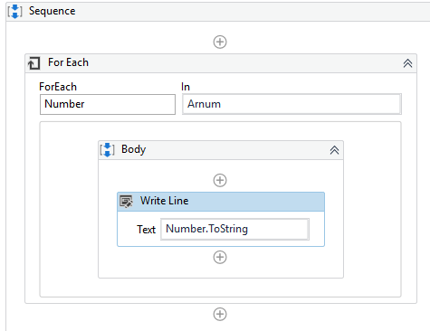
Than Debug and Run:
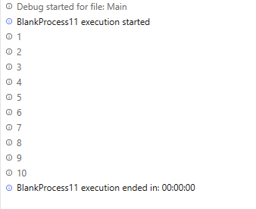

Array of names
- Create variable: name: ArrNames, datatype: Array of(T),
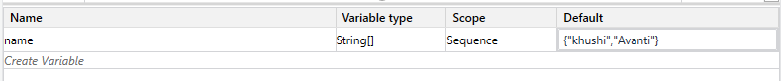
- Create the sequence: For Each > If > then write line
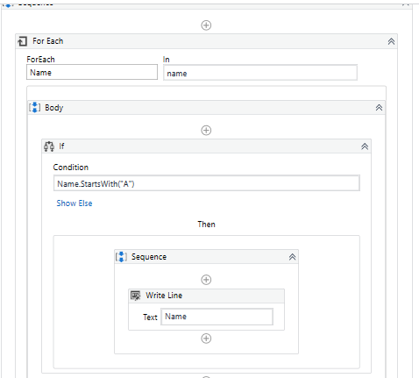

Output
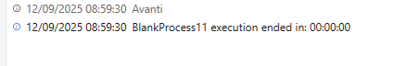

Count Array of names
- Create the sequence: For Each > If > then write line > outside of for each add write line
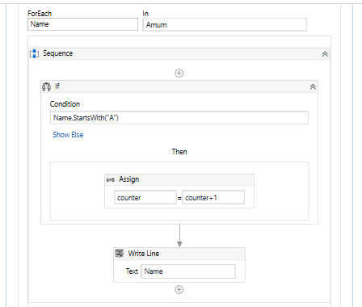
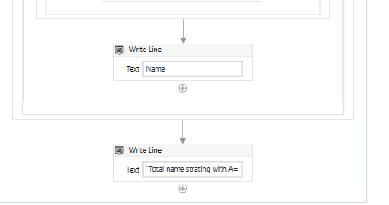

Output
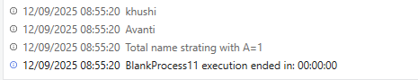

Do while
- Do while activity
- Body: Add Write line: Num.ToString, Add Assign: from: Num / To: Num-1, Condition: Num>0
Flow:
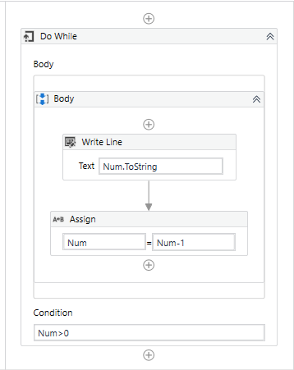
Output:
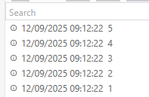
Delay
Flow:
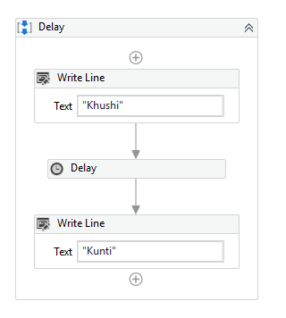
Output:
